Heat- Stress in Cattle: Recognize what it is, what it can do and how to manage it.

Cattle are unable to dissipate excess heat efficiently. Their ability to sweat is poor and they rely more on respiration to cool themselves. A further disadvantage for cattle is the fermentation process within the rumen that generates additional heat that has to be dispersed. (This rumen is a big advantage is cold weather, as the act of fermentation warms the cattle from the inside out.) During grazing and rumination during the day, cattle accumulate a heat load and must dissipate heat when it is cooler, presumably at night. During heatwaves, cattle may accumulate a heat load and nighttime conditions are not conducive for a return to normal

Cattle are mammals and as such have involuntary and automatic methods of regulating body temperature. These methods include shivering when cold and sweating or panting went hot. These processes contribute to an animal’s ability to maintain homeostasis (a constant, stable environment within its own body.)

There is a thermoneutral zone for mammals, including us, that includes the range of temperatures in which we do not use any energy to either stay warm or stay cool. Many life processes are disrupted when temperatures rise above the upper limits of that zone.

Temperatures above the thermoneutral zone for cattle will cause them to expend energy to cool their bodies. Immediate and obvious signs of this include an increased respiration rate, increased heart rate and panting. The animal is using extra energy, but at the same time their feed intake is lowered. Heat stress occurs when the animal can no longer adequately dissipate accumulated heat in its body, and the animal’s performance or health suffers as a result.

Humidity becomes important when calculating potential for heat stress because as humidity rises, the ability of animals to cool themselves by evaporation-transpiration is reduced. As the ability to cool itself is reduced, the animal’s core body temperature will rise, leading to depressed feed intake and eventually to more classic signs of heat stress. If the relative humidity exceeds 50%, the dissipation of heat by evaporative cooling becomes much more difficult, and signs of heat stress may develop sooner.
Heat stress doesn’t have to last for months to have profound effects on animal productivity. In fact, just a few days of high heat, even in temperate climates can have profound negative impacts, with potentially devastating economic losses as a direct result of decreased milk production, reproductive performance, milk quality, growth, and increased animal mortality and health care costs. The time period between weaning and subsequent birth of another calf involves a number of crucial events that can be adversely affected by heat, including rapid fetal growth and the start of a new lactation period. Heat stress at this time can affect normal endocrine function resulting in increased fetal abortions, shortened gestation length, lower birth weight and reduced ability to cycle normally into heat. Heat stress late in pregnancy is capable of altering the growth of the udder and placenta, decreasing the nutrients delivered to the unborn calf, and lowering subsequent milk production.

Identifying animals most susceptible to heat stress.

Feedlot animals that are closest to slaughter are the most susceptible to heat stress.
- They are overweight by definition, and have the smallest amount of lung capacity relative to their body weight. Heavily fed and overweight show cattle are in the same boat. Heavy cattle have a more difficult time regulating their body temperature in hot weather than thin cattle. Feedlot animals will show more dramatic signs of heat stress than will pasture cattle. Show stock are always a concern as the vast majority of fairs are held during the heat of the summer. Cattle fattened on typical show rations can be very stressed due to heat. It is important to provide shade and fans.
- The beta-agonist feed additives used to increase carcass muscle may contribute to the development of heat stress. Market cattle become inefficient during the last month of the finishing period, as a result the animal is accumulating less muscle and more fat. Beta agonists redirect energy to more protein synthesis rather than fat synthesis. i.e.. add more lean muscle to carcass weights. Both ractopamine (Optiflexx)and zilpaterol (Zilmax) seem to increase death losses in feedlot cattle, most likely to occur in hot summer weather. Zilmax, in combination with certain hormone implants, can exacerbate this effect, even in Bos Indicus (Zebu or Brahma type)breeds. These agents are approved only for use in market steers and heifers within 28-42 days prior to slaughter and may be on board market cattle during hot summer fairs and cattle shows. Fat cattle are already at higher risk for heat stress and beta-agonists can make matters worse. Incidentally, these products are both unethical and illegal to use in any breeding stock. They are considered a medicated feed additive, and as such, may not be used in any extra-label manner.
*All medicated feed additives are to be used in accordance with the FDA approved label. Extra-label use of medicated feed additives is strictly prohibited by federal law and no one has the authority to adjust the dose as labeled, including veterinarians. This is different than the laws governing use of other drugs in veterinary medicine.

Very young calves, very old cattle and animals in poor body condition are also at increased risk. They do not have the body reserves to withstand prolonged periods of heat.

Cattle with dark hides and hair are also at higher risk: deaths of black hided cattle on pasture without shade and limited supplies of water have been recorded in numbers which appear to be statistically above those for light colored cattle. Studies have confirmed that closely related cattle with dark hide colors suffered from a 2 degree F higher core body temperature than their contemporaries with lighter-colored skin.

Have a plan in mind should the risk of heat stress become imminent.

Water: Animals suffering from heat stress need to drink water. Water access is something that is commonly overlooked in more northern and temperate climates, often because large tanks of water are prone to freezing in winter, thus smaller and more efficient tanks or automatic, heated waterers with very limited access are popular. During periods of high heat, the same water access used successfully during colder months may very well prove to be inadequate in hot weather. Cattle require large volumes of water anyway; but that water requirement can double between what is needed at 70F vs 90F. When temperatures are over 80F, cattle will require more than 2 gallons of water per 100 pounds of body weight, or roughly 24 gallons per day for a 1200# cow. Heavy milking cows will require considerably more water per day than a dry cow of roughly the same weight. Furthermore, boss cows may monopolize the access to water just like they do hay feeders in the winter, preventing subordinate cattle from drinking. If you have only limited access to water, consider bringing in portable tanks during periods of high heat. It is also imperative that water supply lines and water pressure is adequate for the increased consumption during hot weather. Don’t forget the calves!! You have to ensure that all animals, including calves, can drink. If you are filling tanks by hand, or have automatic waterers, make sure that even neonates can access the water. Babies will drink water in addition to milk from the cow .The sides of the water tank need to be low enough for calves to get their necks over and the water level must be high enough within that tank for the calves to reach. If you run above ground lines into tanks, remember that the water inside those lines can become very hot. Cattle don’t seem to like hot water and will stand around and bawl rather than drink; it may only require one brave cow to consume the first drink and get those lines full of cool water, but you may have to be that cow. Don’t hesitate to dump the tank to start cold water through the lines.

Change the feeding time.
If animals are in lots with limited feeding, changing feeding time to late afternoon or evening can aid in reducing heat load. Rumen fermentation will take place during night time when temperatures should be at least somewhat cooler. Body temperature reaches a peak several hours after feed consumption in cattle. If penned cattle are fed in the morning during periods of high heat, the heat generated by rumination will need to be dissipated during the hottest part of the day, when it is the most difficult to disperse. Consider reducing the actual amount fed during and several days after a high heat stress event. The effects of heat stress may linger, and increasing metabolic heat production may cause problems for individual animals that have not fully recovered from the heat. Obviously, this does not apply to cattle on pasture.

Air circulation can be critical in helping alleviate and mitigate the effects of heat stress. A wind or breeze moving over the cattle promotes evaporative cooling. Unfortunately, all those trees and other windbreaks so useful in winter become a potential problem during high heat as they block air circulation in the summer. Remove unnecessary wind breaks if possible (don’t cut down the trees, they do need those for shade) but something as simple as mowing tall weeds may improve air movement. Flat pastures or pens can benefit from mounds built to increase elevation in select areas and hopefully allow cattle to find a breeze. Ventilation should be provided for housed animals by fans or keeping windows open. Sunshades should be at least 10 feet off the ground to allow for adequate air movement.

Physically cooling the cattle can be one of the most useful techniques to minimize heat stress, if the cattle are used to hoses or sprinklers. Wetting the hide is a good way to cool an animal already suffering from heat stress. Gradual wetting should be done with cool, rather than cold, water. Wetting may need to be repeated until the heat stress symptoms are relieved. A cool (not cold) water drench orally is extremely effective in reducing core temperature of heat stressed animals. This should be performed by someone experienced in drenching animals.
Sprinklers can provide some relief to heat-stressed animals. The water droplet size should be large: misting (small droplets) may only add humidity and moisture to the air without actually doing any cooling. Animals may be frightened of sprinklers if they have not been acclimated to them and this can add to their level of stress. Indoor temperatures can be lowered by spraying cool water on the roofs and walls of building that house animals. Wetting the ground will aid in cooling cattle, as will direct application of cool water.

Shade is essential for cattle in hot weather. Solar radiation contributes significantly to body temperature. Consider moving cattle to alternate pens or pastures that can provide improved shade, even if the pasture has been grazed down and is “out of rotation”: the cattle’s comfort must come first. Shade can be provided in a number of ways; by trees, buildings or sunshades.

Adding straw bedding on top of black or dark dirt can reduce the ground surface temperature by 15 F compared to the original dirt. Wetting the bedding before or shortly after putting it down can further reduce that ground temperature.

Control flies, which contribute to bunching of cattle.

Do not work cattle during extreme heat. If it is necessary to do so, work small groups as calmly as possible, provide water in holding pens and start and finish in the morning. The natural body temperature of cattle will peak in the early evening, just as daytime ambient temperature does, then decline during the night and reach a low point just before dawn. If it is necessary to work cattle during hot weather, it is best to do it in the morning, when their body temperature is at its lowest point. Do not ever work cattle in the evening after a heat-stress day. They need the evening to recover from the heat load built up over the course of the day. Their body temperatures are at their highest at this time and this usually goes hand in hand with the highest temperatures of the day. Processing cattle can elevate their body temperatures by ½ to 3 ½ degrees F and can be the final straw for an already heat-stressed animal.

New introductions will undoubted cause infighting; it is critical that new members to the herd be introduced during cool periods. Resident cows or even yearling heifers may gang up on newly introduced animals, chasing, butting and stressing. One on one with females is not as problematic as multiple herdmates challenging a single newcomer. Females do not seem to be as driven to establish dominance when the weather is hot and overbearing, but in the case of multiple herdmates, one or two may challenge the newcomer, only to have a couple more take over when the original chasers get too hot and tired of the game. This can continue for an extended period of time, never granting the newcomer any reprieve. Serious heat stroke can be the result even on a moderate day. In the case of bulls; use extra caution as most will fight until one gives up and flees. Depending on the disposition of the animals, this can result in a fight to the death. Even one on one, if hot weather is involved, testosterone driven attempts at dominance may continue past the point of no return: heat stroke and death for one or both participants is possible. The hotter and more humid the weather, the greater the probability of a fatal outcome. Never introduce new animals to the herd during a heatwave.

Transport of cattle should be avoided during hot weather. If it must be undertaken, a few precautions are essential. Cattle should not be crowded, the more room the animals have between them the better. Travel should be conducted during the evening, nighttime and early morning hours, with frequent stops for water. Transport of heat stressed cattle to slaughter facilities may have a negative effect on carcass quality, resulting in dark cutters.

Avoid vaccinations during severe heat: there may be a fever spike following vaccination, coupled with heat stress, which can cause body temperature to rise above the normal for cattle (above 101.3-102.8).

Feed additives may partially alleviate heat stress through increased heat dissipation. Several studies have shown that certain fungal cultures in the diet decreased body temperature in hot weather (but not in cold). Encapsulated niacin has been shown experimentally to increase sweating rates and lower core body temperature. Tasco (a brown seaweed harvested in Nova Scotia) has been used to reduce core body temperature to aid in the control of fescue toxicosis. (a subject for another article .)

Recognizing Heat-stressed animals:

The signs of overt heat stress are not hard to imagine. They may include animals bunching together, seeking shade, panting, slobbering, foaming around the mouth, open-mouthed breathing (particularly distressing to witness in cattle and cats, by the way) lack of coordination and trembling. If you witness any of these signs in your cattle, immediately try to minimize the stress to the animal. If you are in the middle of working cattle, stop. Continuing may result in fatalities. Sick animals or animals recently recovered from illness will be more susceptible to heat stress than healthy cattle and will usually be the first to show signs of heat stress and will also be the most severely affected. Any temperature above 75F may be high enough to cause heat stress.

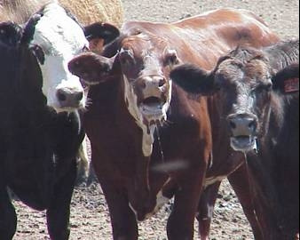

Typical visible signs of heat stress.
- Increased thirst.
- Decreased activity
- Agitation and restlessness
- Bunching (in the shade, if it is available)
- Increased urination, urine may be darker in color if accompanied by dehydration.
- Crowding over water troughs.
- Refusal to lie down
- Seek shade or align themselves with the sun if there is no shade
- Splash water if it is available.
- Slobbering or drooling
- Panting
- Open mouth breathing
- Increased respiratory effort with pushing from flanks
- Tongue protruding
- Lack of coordination and trembling
- Become unresponsive, lie down and start to die when body temperature reaches 41.5C (106.7F)

The unseen effects of heat stress

- pH of rumen is lowered
- rumen and gut motility is decreased, slowing the passage of feed through the intestines.
- Increased peripheral blood flow.
- Increased thirst and concomitant water consumption causes heavy loss of electrolytes (particularly sodium and potassium)
- Reproductive hormones affected
- Embryonic development is affect
- Bicarbonate is lost
- Stress hormones appear in the blood
- Body attempts to shut down metabolic processes and protect heat-sensitive tissues
- Immune function decreases, increasing susceptibility to disease organisms
- Lower conception rates
- Lowered fertility in bulls
- Increased fetal death
- Increased neonatal deaths
- Loss of homeostasis (ability of the body to regulate physiologic processes)

This last list is critical because of the very fact that these are unseen effects not necessarily attributed to the heat. Heat stress can dramatically affect the reproductive performance of cattle within days. It can negatively affect all aspects of reproduction. Proper cooling is still the best way to improve fertility during heat stress.

Effects of heat stress on Bulls
Bull testicles must be 2-6 degrees cooler than core body temperature for fertile sperm. Increased testicular temperature reduces semen quality. Bos Taurus bulls, of which Highlands are considered, are more susceptible to semen damage induced by high ambient temperature than Bos Indicus (Zebu or Brahman type)bulls or crosses of the 2. In Bos Indicus and their crosses, decreases in semen quality were less severe, occurred later and recovered more rapidly than in pure Bos Taurus bulls. In a very quick summary, there are 3 basic cell types in the testes; Sertoli cells, Leydig cells and the germ cells (spermatogenic cells.) Within the seminiferous tubules of the testes, the spermatogenic cells actually develop into sperm, while the Sertoli cells support and provide nutrients to the developing sperm. Outside the tubules and making up the remaining bulk of the testicles are the Leydig cells, which produce testosterone. The effects of increased temperature on testicular cells are detrimental to Sertoli and Leydig cells, but the so called germ cells are most sensitive to heat. All stages of sperm development are susceptible, with the degree of damage related directly to the extent and duration of the increased testicular temperature. Assuming no permanent damage to the testicles, sperm morphology will return to normal (or more correctly, pre-insult values, which may or may not have been normal to begin with) approximately 6 weeks after the heat-related damage has occurred.

Semen quality is decreased when bulls are continually exposed to temperatures of 86F for 5 weeks, or 100 F for 2 weeks, despite no apparent decrease in libido. Heat stress lowers sperm concentration, decreases motility and increases the percentage of abnormal sperm in the ejaculate. Despite observations made during some studies, there is no doubt in my mind that bulls do suffer lack of libido during hot weather.

Effects of Heat Stress on the Cow

Stress associated with high heat in combination with high humidity is a known factor in decreasing pregnancy rates in cattle. As early as 1974, studies verified that pregnancy rates of dairy cows declined from 55% to 10% when the THI increased from 70-84. Heat stress is known to delay puberty in heifers, cause anestrus in cows, depress estrous activity, induce abortions and increase prenatal mortality.

Elevated body temperatures influence ovarian function to the point of failure to ovulate, lack of visual evidence of estrus, lack of implantation, embryo disintegration and fetal absorption. One study showed that beef cows with an average body temperature of above 40C (104F) had a 0% conception rate. If you have ever taken the rectal temperature of a Highland cow on the hot, sunny day while you had them in the chute for some other purpose, 104F is not that difficult a temperature to reach, particularly with 102.8 still in the normal range.

It takes about 40-50 days for antral follicles to develop into large dominate follicles with resulting ovulation. If heat stress occurs during this time period, both the follicle and the oocyte (the egg) inside the follicle can be damaged, with reduced chances of successful fertilization and development into a viable embryo. Furthermore, heat stress reduces the length and intensity of estrus, to the point that the incidence of anestrous and silent heat is increased. Part of this may be due to endocrine disturbances that are a direct result of heat stress, but part may be due to the reduction in activity seen with hot weather, where increased movement associated with the act of breeding only succeeds in producing even more body heat. (it is just too hot to do anything.) Heat stress actually impairs follicle selection and increases the length of the follicular waves that occur during every estrus period. This reduces the quality of the oocytes , increasing the number of subordinate follicles, while reducing the dominance of the dominant follicle. Fertility is reduced and may result in increased incidence of twinning due to the lack of a single dominant follicle.

Heat stress also reduces pregnancy and conception rates and have deleterious effects on the very early developing embryo particularly at the 2 and 4 cell stages. It can also reduce embryo growth up to day 17, which is a critical point for the embryo in preventing luteal regression and maintaining pregnancy. Smaller embryos are associated with an inability to inhibit natural prostaglandin F2 Alpha, which is the instigator of CL regression (in the exact same manner that a shot of Lutalyse will induce heat or cause abortion. )
In dairy cattle, the likelihood of pregnancy loss has been shown to increase by a factor of 1.05 for each unit increase in mean maximum Temperature-Humidity Index (THI) from days 21-30 of gestation. Heat stress also causes redistribution of blood flow from the inner visceral organs to the outside periphery of the animal, resulting in decreased availability of nutrients and hormones to the pregnant uterus. This causes a suboptimal environment for fertilization, embryo growth and implantation.
Fixed Timed artificial insemination can be used to avoid the deleterious effects of reduced estrous detection and can improve fertility during the summer. Injections of GnRH at the first signs of standing estrus can increase conception rates. These methods however, are time and labor intensive and more applicable to a dairy setting than the average beef herd.

It actually is interesting to track weather history and see just what our animals have had to endure. During the middle of July, in 2013, we had a 4 day period (July 15-19) of unrelenting heat and humidity. Maximum Heat Indexes ran between 120 and 130 before dropping to a more moderate 100 on July 20. August couldn’t compare. Did this affect fertility in our herd? I believe it did. Those cows who might have been bred in the 2nd heat cycle would have been in that critical first 17 days of embryo development when this heat wave struck. Not to mention the bulls’ testicles. We are still waiting for our 2nd grouping of calves. The summer of 2012 was one of the hottest on record for our area of Michigan. That year, a substantial number of our spring calving cows were converted to fall calving cows, instead of eating all the open ones at the end of a very long and incredibly hot summer. Conception rates for December through January breedings were excellent.

Know when to intervene:

Pay attention to both long and short term weather forecasts.

Heat stress is driven by a combination of factors. Temperature and humidity are two of the most important of those factors. Heat load on cattle is cumulative: if the evening temperatures are not cool enough to offload the heat built up during the day, cattle cannot recover before the next onset of severe heat. Temperature alone is not the sole way to evaluate the danger of heat stress. Various indexes have been developed which take into account variables such as heat, humidity and evaporation rate. THI (Temperature Humidity Index) is used almost exclusively when evaluating the risk of heat stress to livestock. The THI may not predict the true extent of heat stress in extensive grazing systems because it does not take into account accumulated heat load. It also does not account for solar radiation (direct or reflected) and wind speed, which can all affect heat load in cattle. The HI (Heat Index) is more commonly known and routinely reported by the National Weather Service when conditions carry an increased risk of heat related health events, mostly for humans, but certainly applicable to livestock and other animals as well. The Heat Index, although designed and calculated with humans in mind, has a threshold that is very close to the livestock Temperature-Humidity Index and can be used in the same manner. The HI does not account for night time cooling. If temperatures remain high during the night, and animals never get the chance to cool down, they become less capable of handling the heat.

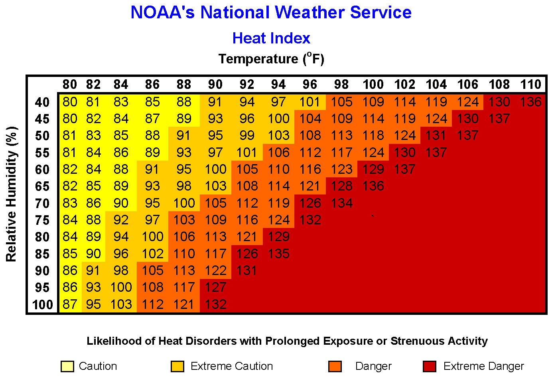

As a general rule:
- Heat Index above 100: stressful for the animal, but tolerable if shade is available or wind speed is at least 10 mph. In the case of show animals, provide shade or moving air via fans.
- Heat Index above 110: stressful period, regardless of wind speed. Shade is required; show cattle require shade and fans, and plentiful access to drinking water.
- Heat Index above 115: Avoid moving or handling animals, particularly those that are slaughter ready (and overfat breeding animals, as many show animals are presented in market-ready condition). Show management should consider postponing the show due to excessive heat.
- Heat Index above 120: No activity should occur for animals or humans. May cause serious health risks or death.

It surprises many people to learn that the heat index values in the chart above are for shady locations. If you are exposed to direct sunlight, the heat index value can be increased by up to 15°F
Examining a Temperature Humidity Index (THI) guide, like the chart below, cattle are in danger of death from heat exposure during the following events:
- The THI is 75 or great for a 72 hour period
- THE THI during a 48 hour period is no lower than 79 during the day and no lower than 75 during the night.
- The daytime THI reaches 84 or higher for two consecutive days.

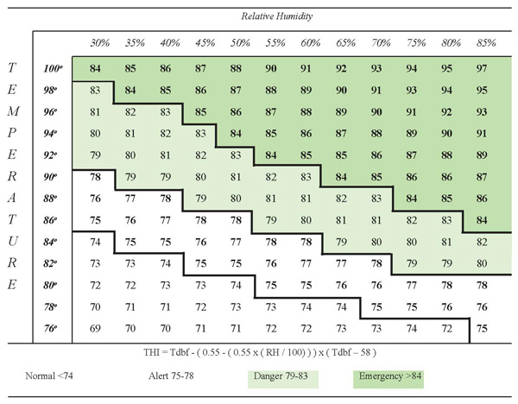

HI is calculated in a very complicated mathematical formula that takes into account at least 20 variables that relate to human comfort levels. It is calculated based on the actual dimension of a given individual (5’7”, 147 # - oh, don’t I wish) with 84% cover (clothes, that is), vapor pressure, sweating rate, and many more. The actual calculation for HI is:
HI = -42.379 + 2.04901523T + 10.14333127R - 0.22475541TR - 6.83783x10-3T2
- 5.481717x10-2R2 + 1.22874x10-3T2R + 8.5282x10-4TR2 - 1.99x10-6T2R2

where T = ambient dry bulb temperature (°F)
R = relative humidity (integer percentage).

THI, on the other hand is far simpler to calculate, should you care to do so. You can always convert to F later.
THI = (Dry bulb temperature ºC) + (0.36 x dew point temperature ºC) + 41.2

As an example of what not to do with cattle in the event of high heat and humidity, the following is a true story as I remember it told to me.
A new breeder purchased a group of bred heifers and cows from a long time Highland cattle owner. These cattle were not handled frequently, could be called “on the wild side”, and were virtually never caught and loaded for any purpose other than sale or slaughter. The purchase involved a trailer full of animals. The seller agreed to load and deliver the cattle: the trip would be an easy drive of about 80 miles, taking roughly 1½ hours. Unfortunately, the seller was either an uncaring, self-serving opportunist only concerned with getting his money for the load, or he just didn’t know any better (he was not a stupid man, so I am leaning towards the first theory,.) The round-up began on a blistering hot Sunday in July. It took most of the day to round up the cattle, or at least this is what was told to the buyer. I don’t know how the “round-up” went, but I believe I can envision it; mass hysteria on the part of the cattle, flaring tempers on the part of the Michigan cowboys. Finally the cattle were packed into the trailer and driven to their new home. As I remember the description given by the buyer: the trailer door was opened and cows literally fell out of it or staggered out on their own. The buyer was not unfamiliar with cattle handling and rearing and instantly recognized the fiasco for what it was; a major mistake and disaster. I am sure she had no idea that the cattle would be stressed to their absolute limit with an all-day chase prior to what should have been a short and uneventful trailer ride. Instead of refusing to pay for the cattle and seeing them sent back to their origin, she instantly dragged out hoses, started spraying the cows down, and called her veterinarian. This good person made a heroic effort to save those animals. If memory serves, by some amazing stroke of luck, all the cattle on the trailer survived and ended up with a wonderful new home. Unfortunately, the fetuses carried inside them did not.

Important points to remember:
- Lean cattle handle heat stress better. (I said “lean” cattle, not skinny, starved cattle. This is not an excuse to underfeed your cows.)
- Heavy cattle don’t handle heat stress as well as their lean herdmates because the increased fat deposition prevents them from dissipating their heat load as effectively.
(This includes many show animals: most Highlands on heavy concentrate feeding expressly for the show ring will be fat cattle. If they look like they are close to slaughter weight, even though they are breeding stock, they will not handle heat stress effectively.)
- Cattle in poor condition from either inadequate feed or health problems, will be less tolerant of conditions ripe for heat stress. Pneumonia in particular, at any time previous in an animal’s life, will leave most cattle with an increased risk of heat stress.
- Temperament plays a small role in heat stress: high-strung animals are more susceptible than placid and calm cattle.
- Previous exposure to high heat and humidity does reduce some of the stress response associated with high heat. Moving cattle from a cool climate directly to an area with a hot environment can increase the animal’s susceptibility to heat stress.
- Solar radiation (sunlight and reflected heat from dark dirt lots, pavement or buildings) is a critical component that increased heat stress and can lead to death loss. Animals kept in dry lots are unable to move away from solar radiation.
- Cattle confined in close proximity seriously influence the temperature and humidity of their immediate surroundings. The risk of heat stress needs to be evaluated at cow level within their confined space, and not outside the lot at human level.
- If Heat Indexes are predicted to be high, and cattle are observed with mild signs of heat stress, consider your options to reduce risk to the animals. Once an animal goes down due to heat stress, you are probably too late to save that animal.

During periods of high heat +/- humidity, know the signs of heat stress and intervene early to prevent severe illness or death. Signs of heat stress, progressing from mild to severe are:

- Increased thirst.
- Decreased activity
- Agitation and restlessness
- Bunching (in the shade, if it is available)
- Increased urination
- Crowding over water troughs.
- Refusal to lie down
- Seek shade or align themselves with the sun if there is no shade
- Splash water if it is available.
- Slobbering or drooling
- Panting
- Dark colored urine
- Open mouth breathing
- Increased respiratory effort with pushing from flanks
- Tongue protruding
- Lack of coordination and trembling
- Become unresponsive, lie down and start to die when body temperature reaches 41.5C (106.7F)

Heat stress is hard on everybody, and certainly our long haired cattle suffer from it as much as others, including ourselves. Combine high heat with humidity, or sometimes only moderate heat with high humidity, and you have a recipe for problems. Be prepared.

